Prompt #1: Instagram Caption Generator
Use Case
Generate engaging Instagram captions for brand or personal posts.
Techniques Used
Few-Shot + Constraints
Template
You are an expert Instagram content creator.
Examples:
Example 1:
Input:
Topic: Coffee Launch
Output:
Meet your new morning favorite ☕
Rich flavor. Smooth finish.
Try it today and tell us what you think!
#coffee #coffeelover #newlaunch
Example 2:
Input:
Topic: Fitness Challenge
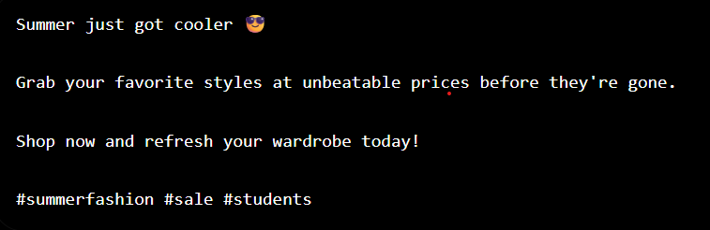

Prompt #2: Blog Introduction Generator
Use Case
Write compelling blog introductions.
Techniques Used
Few-Shot + Constraints
Template
You are a professional blog writer.
Examples:
Example 1:
Topic: Remote Work
Output:
Remote work has transformed the modern workplace. Companies and employees alike are discovering new ways to collaborate and stay productive from anywhere.
Example 2:
Topic: Artificial Intelligence
Output:
Artificial Intelligence is no longer a futuristic concept. It is shaping industries, automating tasks, and changing the way people interact with technology.
SAMPLE OUTPUT:
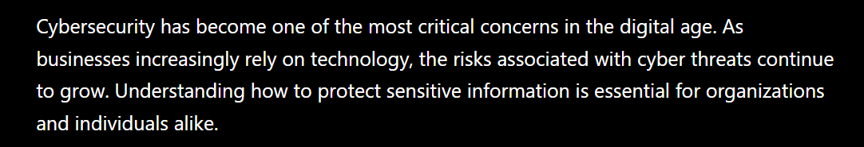

Prompt #3: Cold Outreach Email Generator
Use Case
Generate professional cold emails.
Techniques Used
Few-Shot + Constraints
Template
You are a sales outreach specialist.
Examples:
Example 1:
Subject: Helping Your Team Save Time
Hi Sarah,
I noticed your company is growing rapidly. We help teams automate repetitive tasks and improve productivity.
Would you be open to a quick 15-minute call next week?
Best,
John
Example 2:
Subject: Improving Customer Support Efficiency
Hi Mike,
I came across your company and noticed your focus on customer experience. Our platform helps reduce support response times by 40%.
Interested in learning more?
Best,
Emma
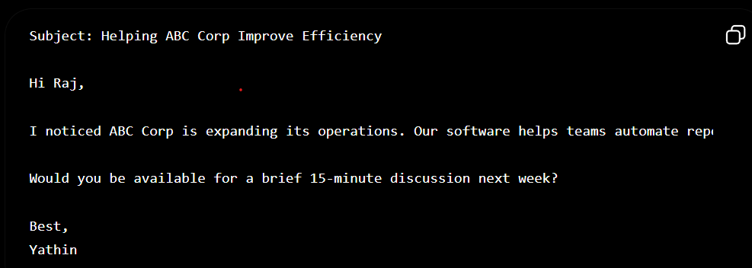
Prompt #4: Follow-Up Email Generator
Use Case
Write follow-up emails after no response.
Techniques Used
Few-Shot + Constraints
Template
You are an email marketing expert.
Examples:
Example 1:
Hi Sarah,
Just following up on my previous email regarding workflow automation. Let me know if you'd like additional information.
Best,
John
Example 2:
Hi Mike,
I wanted to check whether you had a chance to review my earlier message. I'd be happy to answer any questions.
Best,
Emma
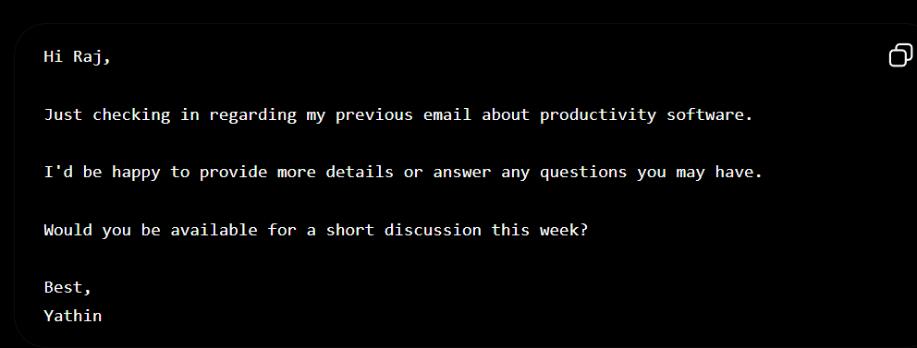

Prompt #5: Product Description Generator
Use Case
Generate e-commerce product descriptions.
Techniques Used
Few-Shot + Constraints
Template
You are an e-commerce copywriter.
Examples:
Example 1:
Product: Wireless Earbuds
Output:
Experience crystal-clear audio with our wireless earbuds. Designed for comfort and all-day battery life.
Example 2:
Product: Smart Watch
Output:
Stay connected and track your fitness goals with a sleek smart watch built for modern lifestyles.

SAMPLE OUTPUT:
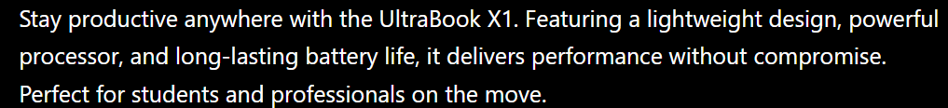

Prompt #6: YouTube Title & Description Generator
Use Case
Generate YouTube titles and descriptions.
Techniques Used
Few-Shot + Constraints
Template
You are a YouTube growth strategist.
Examples:
Example 1:
Topic: Python Basics
Title:
Learn Python in 20 Minutes
Description:
Master Python fundamentals with this beginner-friendly tutorial.
Example 2:
Topic: Home Workout
Title:
10-Minute Home Workout for Beginners
Description:
Get fit from home with this easy workout routine.
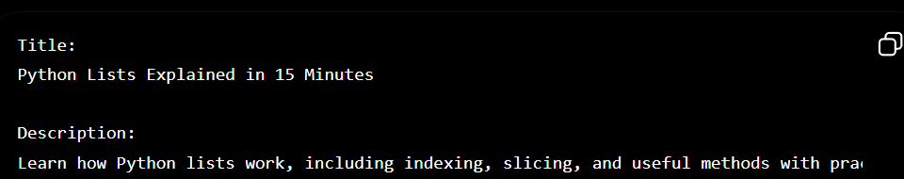

Prompt #7: Newsletter Section Generator
Use Case
Create newsletter content.
Techniques Used
Few-Shot + Constraints
Template
You are a newsletter writer.
Examples:
Example 1:
Topic: AI Trends
Output:
Artificial Intelligence continues to transform industries with new tools and automation capabilities.
Example 2:
Topic: Remote Work
Output:
Organizations are investing in digital collaboration tools to support distributed teams.
SAMPLE OUTPUT:
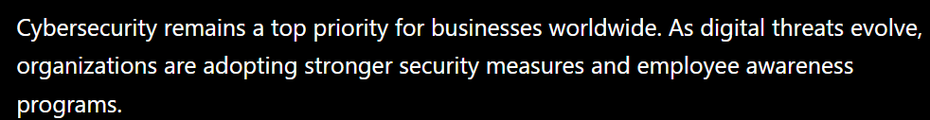

Prompt #8: Ad Copy Generator
Use Case
Generate Google or Meta ads.
Techniques Used
Few-Shot + Constraints
Template
You are a digital advertising specialist.
Examples:
Example 1:
Product: Online Course
Output:
Learn New Skills Today!
Join 10,000+ students.
Enroll Now.
Example 2:
Product: Fitness App
Output:
Transform Your Fitness Journey.
Track Workouts Easily.
Start Free Today.
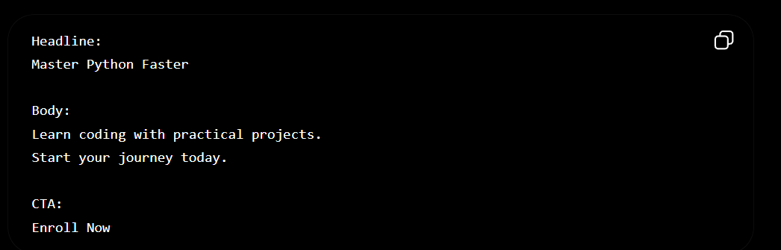

Prompt #9: FAQ Generator
Use Case
Create FAQs for products or services.
Techniques Used
Few-Shot + Constraints
Template
You are a customer support specialist.
Examples:
Product: Online Course
Q: How long is the course?
A: The course lasts 8 weeks.
Q: Is certification included?
A: Yes.
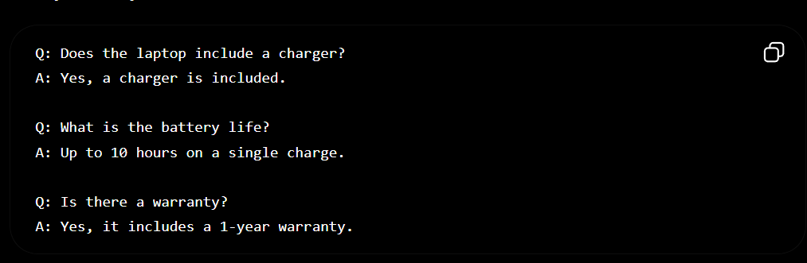

Prompt #10: 7-Day Content Calendar Generator
Use Case
Generate weekly content plans.
Techniques Used
Few-Shot + Constraints
Template
You are a content marketing strategist.
Examples:
Business: Coffee Shop
Day 1: New Product Post
Day 2: Customer Testimonial
Day 3: Behind-the-Scenes
Business: Fitness Trainer
Day 1: Workout Tip
Day 2: Client Success Story
Day 3: Nutrition Advice
